Eco-Engineering Challenge: _____________________________________
PROBLEM

RESEARCH
- .
- .
- .
- .
- .

BRAINSTORMING

DESIGN: labeled drawing

BUILD: insert or paste a photo of what you built

TESTING: describe how you tested your prototype; what worked; what didn’t

REFINEMENTS: how did you refine or modify your design? Did it affect performance?

Eco-Engineering Challenge:
Food Waste
The Challenge
Students conducted a cafeteria audit that showed a massive amount of trash – including uneaten food and a lot of packaging - going to the landfill. Yet some people go hungry from lack of food. The amount of garbage we make is requiring more and larger landfills. And organic (once-alive) waste in a landfill can take years to break down, producing methane gas and leachates when it does. Methane is a powerful greenhouse gas that warms the earth. Leachates leak into ground water and can contaminate it. So how can we reduce the amount of food waste our class sends to the landfill? by using worms?
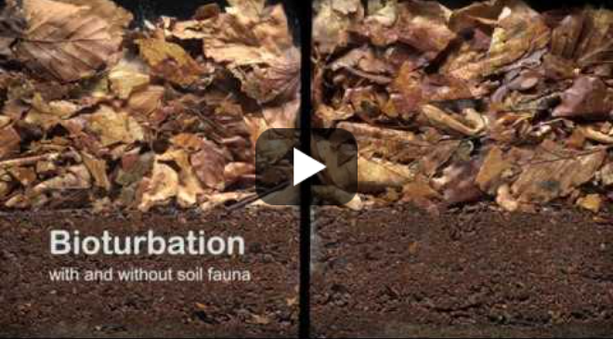https://www.youtube.com/watch?v=Mxp1nnrUG0Q

Constraints
Time: 1 class period for research, design and building
1 class period for testing and refining prototype and sharing it
Specifications: Design must include a suitable habitat for worms and reduce food waste volume
Costs: Each team has a budget of $10. Price tags are on materials.
Safety: Safety glasses must be used if using drill
Clean Up: work stations must be clean at end of period

Materials
- plastic shoe box
- variety of open materials of different gauges (screen, mesh, netting, filter paper, burlap)
- variety of fasteners (glue, duct tape, binder clips)
- variety of colors of construction paper
- variety of types of cardboard pieces (paperboard, corrugated, etc.), newsprint (uncoated)
- price tags
- worms
- safety glasses, drill
- mister bottles / source of water
- variety of food scraps

Curated Research Articles for Jigsaw Classroom (jigsaw.org)
The Habitat of Red Worms (Sciencing.com)
- https://sciencing.com/the-habitat-of-red-worms-13406911.html
Differences between Earth Worms and Compost Worms (Sciencing.com)
- https://sciencing.com/differences-between-earth-worms-and-compost-worms-12498654.html
How to Identify Red Wrigglers at All Stages (ThrivingYard.com)
- https://thrivingyard.com/identifying-red-wiggler-worms/
Vermicomposting 101 (Foodprint.org)
- https://tinyurl.com/ejx9car5

