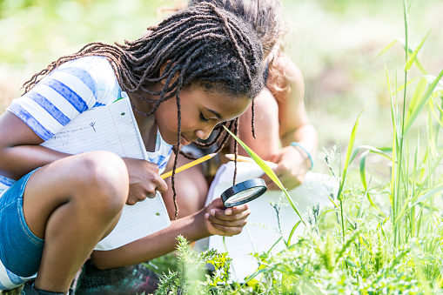

Executive Summary
Outdoor Learning as a Strategy for Safe Reopening of Schools

Georgia schools are entering uncharted territory as they reopen this fall, using a variety of models. Some districts will bring students back to campus, others will stick with virtual learning, and many will try blended or hybrid schedules that mix face-to-face (f2f) and remote learning.

With community spread of the virus spiking this summer and again this fall, it will be important to maintain physical distancing and follow health and safety guidelines from the Centers for Disease Control (CDC) and National Council for School Facilities (NCSF) as schools re-open. Yet even with shift learning, creative scheduling, and adaptive re-use of common areas in the building, many schools still lack sufficient space to accommodate the entire student body while maintaining recommended separation between students.

Outdoor learning, both on school campuses and in the community, can help the physical distancing dilemma by increasing the amount of space available. Learning outside has the added benefit of contributing to physical well-being, mental health, and improved engagement and academic progress, according to recent research. In addition, CDC has determined that outdoor areas are less prone to spread of the virus than indoor settings.

Using the environment to provide a real-world context for learning is an instructional strategy that centers equity and inclusion in education. Impacts of the epidemic and quarantine have resulted in many environmental education providers having excess capacity, unused space, and untapped expertise that could potentially extend available space and provide support for K-12 teachers.

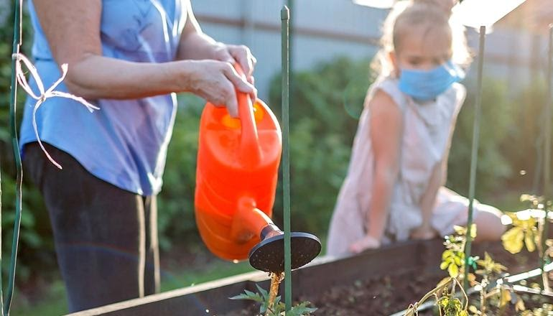
Partnerships between schools and environmental ed providers can offer mutual benefits in any of the following areas:

- Creating Healthy Outdoor Learning Spaces at Schools
- Increasing Capacity of Teachers to Facilitate Outdoor Learning
- Leveraging Learning Spaced in the Community to Benefit Schools
- Expanding Virtual Learning Resources
- Providing Options for Working Parents
- Increasing Cultural Relevance with Outdoor Learning
Background: Why environmental education providers and outdoor learning are keys to safely and equitably reopening schools

Definitions

Environmental Education Provider An EE Provider is an individual or organization that engages students in activities that foster environmental literacy, environmental stewardship and / or environmental justice.

Outdoor Learning refers to educational activities that take place outdoors and provide an authentic, real-world context for learning.

Outdoor Classrooms are any space outside where students can observe phenomena and carry out learning activities, investigations, or projects in any subject. It does not require seating or facilities.

EEA (Environmental Education Alliance of Georgia) is a coalition of organizations and individuals that promote environmental literacy and stewardship, encourages best practices, drive innovative initiatives, forge strategic partnerships, and are committed to the vision of a greener and healthier world for everyone.

Safely reopening schools requires resourcefulness, innovation, and modified procedures for everything from classroom configuration to schedules, transportation, health screenings, meals, and more. The good news is that outdoor learning and environmental education providers can help.

The challenges of bringing students back to school are daunting – from ensuring their physical well-being while community spread of the virus is still a threat; to overcoming the academic “covid slide”; forging new instructional strategies; and supporting families. School closures during the quarantine revealed inequities in education and spotlighted the vital role that schools play in providing educational technology, childcare, meals, and structure in addition to the usual learning activities. As schools reopen, some returning students will likely be affected by the stress of covid-19 disruptions and trauma regarding racial injustice, divisiveness and civil unrest. Many families will be faced with difficulties returning to work, dealing with unemployment, or adapting to new school schedules and expectations. All of these situations place additional stress on educators too. As school districts look to the community for partnerships and support, environmental education providers can offer some solutions.

Outdoor areas, both on and off campus, offer space that can be used for learning, engagement, and health. Across all age groups, access to nature is associated with reduced stress, greater mental health, and increased physical well-being. And during the era of covid, learning outdoors can improve physical spacing, offer lab options that reconfigured classrooms no longer support, and promote active learning in a real world context.

Environmental education organizations in each community, including nature centers, parks, zoos, aquaria, water departments, and non-profit organizations, are experienced in creating learning environments, designing activities backward from the standards, and managing students in hands-on investigations. Whether on campus or offsite, the expertise, capacity, and spaces that environmental education providers can make available will provide invaluable assets for schools districts and family-managed distance learning.
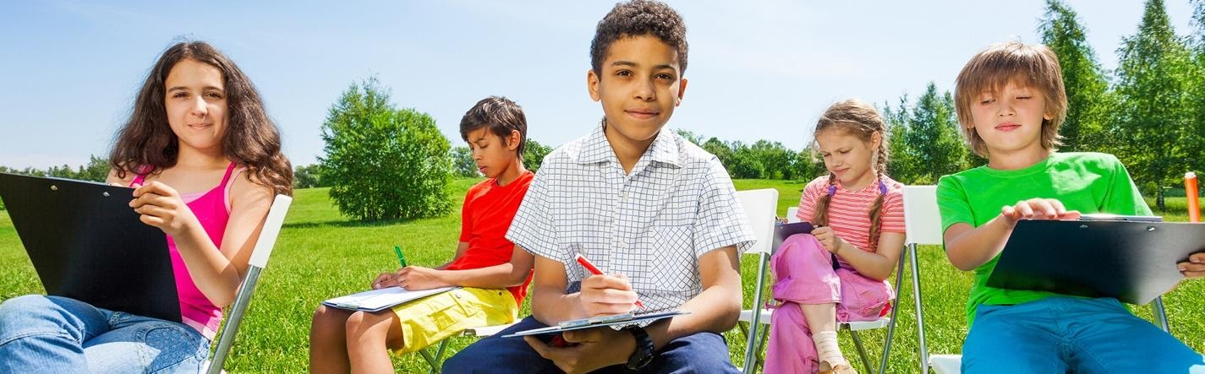
- Creating Healthy Outdoor Learning Spaces at Schools
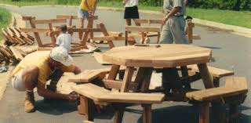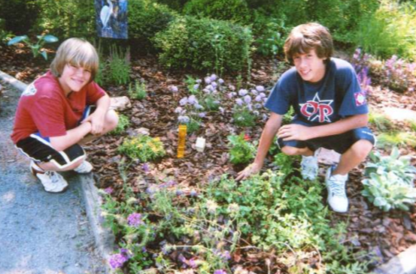
Guidelines under development by the National Council for School Facilities (NCSF) suggest that schools allow 44 square feet per student, which provides the CDC recommended 6 feet of social distance between any two forward-facing students, in addition to a small amount of additional space for a teacher to move about the room. Based on this guidance, NCSF estimates most schools will be able to operate at about 60% of current classroom capacity.

To find additional space, most schools will repurpose specialized areas such as media centers, cafeterias, gyms, and art and music rooms to create additional classrooms. In some cases, this reconfiguration may solve the problem of physical capacity inside the building. However, many schools lack sufficient space even after all of the common areas have been integrated into a plan for re-opening. As a result, school shifts, staggered schedules, or virtual learning may be necessary.

What Schools Should Consider
- When taking stock of usable space for physical distancing, school districts should remember to consider areas on school grounds that could be used for outdoor learning.
- Research suggests that the risk of the spread of COVID-19 is reduced in outdoor settings
- Being outdoors provides healthy opportunities to distance and a context for relevant, real world learning.
- Outdoor learning provides great opportunities for observing phenomena, engaging students in science an engineering practices, and deepening student engagement in making sense of real-world science.
- Science is not the only class suitable to learn outdoors. Anything subject can be taught outside.
- While the weather is not always conducive to outdoor learning, Georgia’s relatively mild climate helps, and shade or rain shelters can extend the days when students can comfortably learn outside.
- Despite a common perception of students in an outdoor classroom being seated on rows of benches facing a lectern, neither amphitheaters, pavilions nor permanent structures are needed.
  - Prioritize work surfaces to promote active investigations, rather than benches for passive learning.
  - Outdoor learning spaces can be inexpensive, versatile, and even portable.

How EE Providers Can Help
- Local non-profits and environmental education providers are expert in creating outdoor learning spaces. They may be able to inventory campus assets and offer valuable advice and assistance with planning.
- Some of the most effective “outdoor classrooms” can take the form of school gardens, 5-gallon bucket “seats” with clipboard “desks”, weather stations mounted on pre-fabricated sections of wooden fencing, cable spools used as tabletops; or half picnic tables (flip-top benches) and tents. Environmental ed providers can often provide plans and instructions, help source materials or kits, and offer advice.
- Most districts have an approval process that leaves some improvements to the discretion of the principal while requiring others to be approved by the district. Pre-fabricated kits are easiest to assemble; do not require approval by an engineer; and reduce a school district’s liability relative to custom designs.
- Inexpensive pergolas, fabric shade screens, and open tents can extend outdoor learning “seasons.”
- Target or Home Depot employees, Telephone Pioneers, Master Gardeners, Scouts, parents, and volunteers may be willing to contribute materials, offer discounts, or assemble outdoor learning stations.
- For ideas and assistance planning and creating learning spaces on school grounds, schools should consider consulting and partnering with local environmental education providers or park managers.
- Increasing the Capacity of Teachers to Facilitate Outdoor Learning
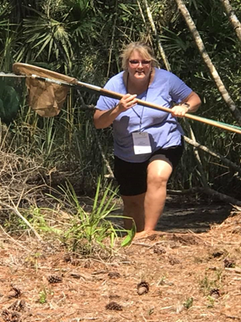
The reopening of schools will require teachers to adapt to yet another “new normal” of instructional strategies. Depending on the district’s reopening model and whether it is tiered, teachers may need to reconfigure their classrooms, institute disinfection protocols between classes, create individual supply kits or lab set-ups if sharing is prohibited, convert hands-on activities to virtual assignments, continue to create distance learning content, and also create work packets for students without internet-connected devices.

If outdoor learning spaces are available, many teachers will be prepared to take advantage of this opportunity based on previous professional learning. Georgia is one of the few states that has an accredited certification program in outdoor learning: Advanced Training in Environmental Education in Georgia or ATEEG, offered by the Environmental Education Alliance [EEA] and University of Georgia. Teachers who are less comfortable outside may benefit from participating in environmental education workshops, conferences or symposia, offered by EEA and many ee providers.

At a time when CDC recommendations discourage parents in the classroom due to the risk of spreading covid-19, teachers will be without “Earth Parent” volunteers who would otherwise assist with management of students outdoors, and help set up and break down field investigations to save the teacher time. In the absence of such support, schools and school districts may turn to community ee providers for assistance.
What Schools Should Consider
- CDC guidelines make it difficult to use parents as volunteers. But the guidelines allow partnering with experienced, local environmental educators for long-term assistance with outdoor learning, including planning, classroom management, instruction, set-up, clean-up, etc.
- Inventory and assess the campus and school grounds for potential outdoor learning spaces.
- Leverage the expertise of environmental-education-providers to offer professional development and training for teachers.
- Consult EE providers for help assessing the campus for possible outdoor learning spaces and for recommendations about maximizing use
- Increase teachers’ comfort and capacity to teach in outdoor classrooms and other learning spaces (such as school gardens, greenhouses, and nearby green space)
- Use community-based programs such as nature centers, science centers, watershed education programs, and others that have the expertise to organize and set up outdoor learning stations
- Partner with nonformal program providers who are skilled at working with teachers to design and implement programs aligned with curriculum standards.
- Engage nonformal educators who can serve as staff, teaching assistants, or content specialists to assist formal classroom teachers and to support outdoor learning.
- Explore ways to use outdoor spaces to teach the Georgia Standards of Excellence (including school gardens, greenhouses, field investigation areas, sports facilities, parking lots, etc.)

How EE Providers Can Help
- EE providers should be prepared to help schools design and create outdoor learning spaces.
- EE providers are trained to use the schoolyard and other natural environments as a context for learning across the curriculum; have expertise in class management and engaging students in outdoor settings, and are often trained to address the physical health and safety of participants outdoors.
- Environmental educators can partner with schools to help facilitate small groups safely
- Some EE providers offer teacher training such as Project WET, Project Wild and Project Learning Tree
- Many EE providers can help schools design simple outdoor learning spaces on campus to enhance learning (i.e. shade structures, pollinator gardens, bird feeders, habitats, learning stations, etc.)
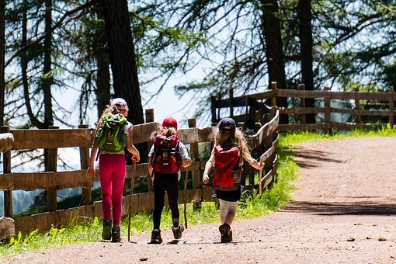
- Leveraging Spaces in the Community to Benefit Schools
Environmental education (EE) providers and outdoor education spaces in communities can be leveraged to provide additional learning areas and educational opportunities where students can be safely distanced. Many ee providers have been temporarily closed, and some will remain so for as long as schools are unable to participate in their programs. Partnering with these community-based organizations, such as nature centers, parks, and outdoor schools, is one way to increase capacity to maintain distance between students, while providing enriching educational experiences and equitable access to nature. It is also an opportunity to engage talented and experienced non-formal educators in supporting teachers.

What Schools Should Consider
- While field trips may not be possible during the epidemic, nature centers, parks, zoos, aquaria and other off-campus environmental education providers may have excess capacity during this time, including:
  - unused space and possibly even internet access for virtual learners;
  - available staff in safe settings, who may be able to host virtual learners when parents have returned to work and cannot supervise learning at home;
  - locations for a hybrid or “shift” model, where students spend alternating days off campus (and transportation is provided by parents)
- Be aware that community-based programs are already adhering to the same health and safety standards as schools, as determined by state and local health departments, to accommodate safe distancing, frequent hand-washing, regular cleaning of high touch surfaces, and other guidelines to protect the health and safety of visitors.
- Leveraging opportunities with environmental and outdoor education programs, which are already designed for outdoor learning, can maximize distancing and minimize risk of spreading the virus
- Consider rotating appropriately-sized groups to partner facilities over the course of the school year for equitable access (with time in between groups for adequate cleaning).
- Streamline planning for extended or multi-day field trips by providing tools such as annual and/or digital permission slips.
- Involving students in outdoor learning as part of a rotating schedule can provide relief from screen time and increase engagement
- Many environmental education (EE) providers also have indoor space available and can accommodate students whatever the weather
- EE providers often have capacity and expertise to deliver project-based learning experiences and in-depth STEM investigations that would be difficult to replicate in a classroom setting

How EE Providers Can Help
- EE providers can organize access and staffing to accommodate smooth student drop-off and pick up logistics for parents
- EE providers can prepare to deliver standards-based learning activities and collaborate with schools to assist with or create new content, as needed
- EE providers may be willing to restrict public access to facilities during designated times when working with schools or parent groups to serve students

- Expanding Virtual Learning Resources
Many school districts are employing strategies for reopening schools that involve continuation of virtual learning for some or all students. Most outdoor and environmental education providers can provide content-rich virtual field trips and tours, webinars targeted to students, remote Ask an Expert sessions, or other digital content. These virtual resources can enliven the typical Zoom, Meet, or face to face classes; engage students more interactively than lecture and text-book driven learning, and provide a break for the classroom teacher.

What Schools Should Consider
- Ask EE Providers about virtual field trips and tours available in your area, if actual f2f field trips are not practical, note that the virus opens new windows of opportunity for virtual learning with ee providers outside your immediate area.
- Seek opportunities for students to explore new places and interact with environmental educators online
- Some environmental education providers are available for Zoom with an Expert sessions, to answer student questions.
- Environmental education providers may be able to offer asynchronous webinars or to live stream educational programs for schools, customized by grade level and standards, for less than the cost of face to face field trips.
- Nonformal educators may also be able to supplement learning opportunities for students outside of school time, providing de-facto after school programming for working parents.

How EE Providers Can Help
- Many ee providers are already creating resources in virtual mode, creating and distributing educational tours, programs and presentations.
- EE providers may also be able to accommodate “pods” of learners outside the school day with online content.
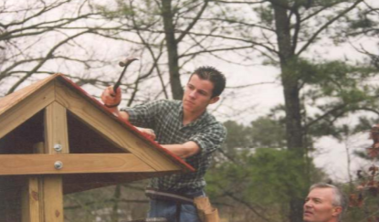
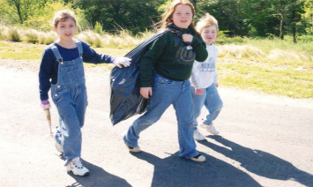
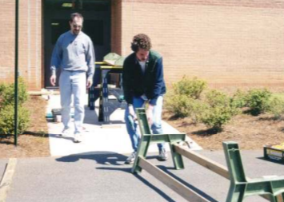
- EE providers may invest in resource-creation tools such as 360 degree cameras; virtual tour creator software, and other apps that make it easy to present virtual field trips or to film on-demand tours that enable students to explore and investigate.

- Providing Options for Working Parents
As schools modify schedules and parents return to work (or attempt to increase productivity while working from home) families of students with partial or full-time virtual learning will continue to face childcare challenges. EE providers may be able to offer in-person supervision of small “pods” of students who follow teacher-directed online learning; provide after-school care; or 5th day enrichment programming for school districts that go to a four day week, to accommodate the increasing responsibilities and preparation time needed by K-12 teachers.

What Schools Should Consider
- Developing relationships with community-based environmental education partners can contribute to student success by creating support networks for families.

How EE Providers Can Help
- EE providers may have excess capacity (due to their facilities being closed or in limited use) and therefore be able to pivot toward providing support for families during and after the school day.
- Increasing Academics & Cultural Relevance with Outdoor Learning
The downsides to virtual learning fall disproportionately on low income students, children of color, and rural communities. In addition to lack of technology and internet, these families are more likely to have working parents unable to supervise children learning from home and students whose responsibilities – including work or taking care of siblings – may limit their ability to participate in remote classes. Children in Black and Hispanic communities are disproportionately likely to be hospitalized by covid-19.
What Schools Should Consider
- Outdoor learning provides opportunities for students who struggle with virtual learning to be more successful academically, leveling the playing field by focusing on real world phenomena.
- Outdoor learning also has the potential to make all students’ experiences relevant by emphasizing use of science and engineering practices to make sense of phenomenon, rather than prior knowledge, exposure, and perspective or worldview.

How EE Providers Can Help
- EE providers can help schools create opportunities for authentic problem-solving, data collection, field investigations, and real world science.
- Outdoor learning presents fewer health risks for students, faculty and staff because of better air circulation and distancing opportunities, than classroom- based learning.

Conclusion
School districts face enormous challenges as they re-open for the 2020-2021 school year. The good news is that there are community partners that can provide support, leverage resources, and reduce risks of spreading the covid-19 virus. Nature centers, park systems, watershed departments, zoos, aquaria and other environmental education providers are willing collaborators in re-imagining learning; and bring to the table teaching expertise, excess capacity, physical space, and effective outdoor education models that can help schools overcome the challenges of providing safe and effective learning during the epidemic. In addition, access to outdoor learning reduces screen time and increases engagement: two of the biggest disadvantages of virtual learning.

Articles
  - Fauci: Schools Should be Outdoors As Much As Possible US News Aug 13, 2020
  - Will The Outdoors Become the New Classroom of the Covid Era? Governing Aug 28, 2020
  - You’re Less Likely to Catch Corona Virus Outdoors May 17, 2020
  - How Green Schoolyards Can Help Make Schools Safer this Fall Finding Nature News Sep 4, 2020
  - Teach Me Outside Nature Based Maine September 14, 2020
  - Concern of the Future of Outdoor Learning Centers in Scotland September 4. 2020
  - How Outdoor Learning Can Control Covid Transmission in Schools Green Schoolyards Sep 1, 2020
  - Equity and Public Space August 20, 2020
  - Outdoor Desks Replace Indoor Classes as a Way of Dealing with Covid-19 in Schools Aug 7, 2020
  - What if We Radically Redesigned the New School Year? Chicago Unheard July 30, 2020
  - The Push to Move Classrooms is Gaining Momentum New Yok Magazine Jul 29, 2020
  - Let NYC Schools Use Outdoor Learning August 6, 2020 - webinar
  - 10 Tips for Outdoor Learning from Scottish Schools August 10, 2020
  - A California Collective Makes the Case for Outdoor Schooling PBS August 2, 2020
  - Why Can’t We Just Have Class Outside? The Atlantic July 28, 2020
  - How to Re-Open the Economy without Killing Teachers and Parents New York Times July 20, 2020
  - Outdoor Learning a Key to Re-Opening Schools The Atlantic
  - Outdoor Learning Model for Return to School After the Pandemic The Guardian May 10, 2020
  - Schools Beat Earlier Plagues with Outdoor Learning New York Times, July 17, 2020
  - Returning Safely to In-Person Instructions; What Educators Need to Know NEA Today July 13, 2020
  - Why Outdoor Learning May Be the Key to Safely ReOpening Schools Bioneers 2020
  - How to Re-Open Schools – What Other Countries can Teach Us New York Times July 11, 2020

