TOOLKIT
for EE Providers, Outdoor Learning Specialists, and Green Space Managers
on Partnering with School Districts
To Re-Open Georgia Schools Safely and Equitably
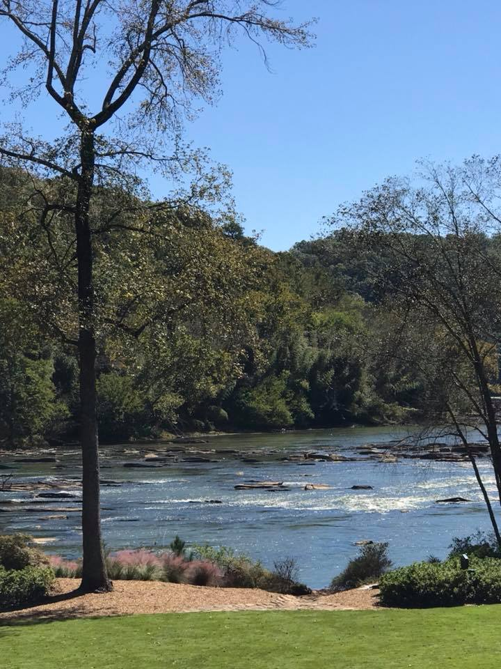
Environmental Education Alliance (EEA) surveyed environmental educators, schools, nature centers, zoos and aquaria during the pandemic to find out how such organizations were faring. Unsurprisingly, many Georgia environmental education providers temporarily closed, the demand for face-to-face programming is down amid school closures, the need for physical distancing has rendered traditional interactions with visitors or students impractical, and staff members are idled.

Yet communities are becoming increasingly aware of the value of being outdoors for the reduced risk of spreading the virus as well as an increased sense of mental health and physical well-being. Since the state has “opened up,” throngs of Georgians are escaping the confines of home to bask in the sun, hike, bike, enjoy nature. Despite the popularity of outdoor recreation, the impact of canceled events, lost revenue, and the inability to generate income through traditional programs has left most nature centers and environmental education providers with excess capacity, unused space, and untapped expertise.

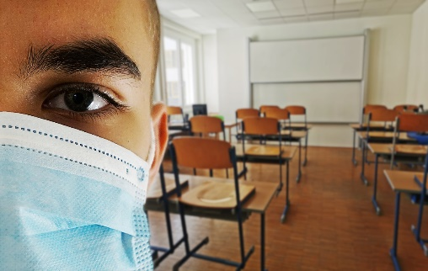
Meanwhile schools districts are making plans to reopen in the fall with a variety of models that include in-classroom and at-home learning. Despite their best efforts to reconfigure classrooms, schools are typically able to accommodate only 60% of students according to spacing guidelines from the Centers for Disease Control (CDC). As a result, many districts have been forced to consider shift and alternating day schedules, continued distance learning, blended models, and shelter-in-place classrooms, amid stringent health and safety protocols.

But what if the unused space on school grounds were factored into schools’ reopening plans, along with the untapped expertise of environmental educators who have been idled by covid closures, and the excess capacity of nature centers and other open spaces in the community? What resourceful and creative strategies could be considered if environmental education providers were at the table alongside school district administrators and educators, as re-opening plans are made? And since distance learning proved least effective with students in under-resourced neighborhoods where lack of access to internet-connected devices, competing student responsibilities and distractions, and parental work schedules have reduced opportunities for family-supported learning, what options might outdoor education provide for making school re-opening more equitable and inclusive than school closures were? The purpose of this toolkit and the accompanying document: EEA’s Strategies for Reopening Schools with Outdoor Learning, is to open doors for Georgia’s environmental education community, support K-12 teachers as they grapple with the ever-changing “new normal,” and offer better options for students and their families.
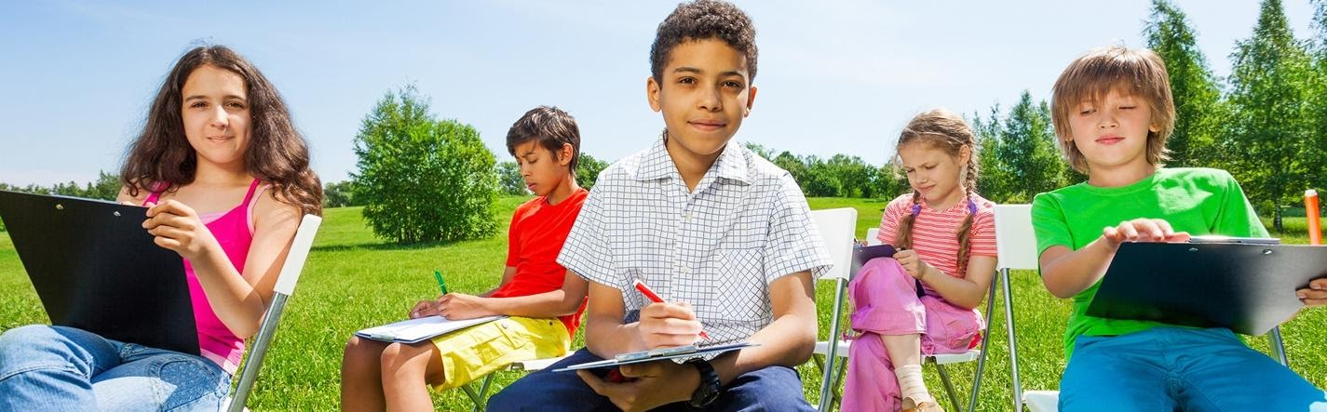n
Getting Started
Customize this TOOLKIT to present yourself and your organization to school districts
- Complete a one page Organizational Profile using the template at the end of this Toolkit. Replace all red type with your own information, and delete parts of the checkmark list which do not apply.
- Add your own logo to the organizational profile and co-brand it with EEA. Use the template by itself or as a cover sheet for EEA’s Strategies for Reopening Schools with Outdoor Learning or NAAEE’s eeGuidance document
- Add Specific State/Province Related Guidance: If your local school district(s) have specific reopening requirements or recommendations, this document can be modified to meet those needs. You might want to provide links to your state/province guidance in this document.
- Add Exemplars: If you know of schools or districts in your area that were using these approaches pre-COVID, consider adding sidebars that help the readers see these practices in action.
- Contact School Districts: Gather support and help from other EE providers in your area by having them sign the Strategies document; share your customized Organizational Profile with local schools and districts while requesting a seat at their planning table, a chance to explain your capabilities, and willingness to be resourceful and innovative while helping problem-solve.

Upload your Organizational Profile (see last page) to the www.eeingeorgia.org web site, where EEA will refer school districts that are looking for local outdoor learning or environmental ed partners.

Provide information about your capabilities on this spreadsheet for quick reference

Share a press release with print and television news outlets in your area
  - Feel free to use the EEA press release or the NAAEE’s press release, as-is
  - OR Customize a press release using the template here. EEA and NAAEE will be issuing press releases on Wednesday, July 1, 2020. There is more information about press releases and roll out strategies below.

Use social media to promote the Best Practices for Reopening Schools with Outdoor Learning document. Sample social media posts may be found here.

Send a letter from your organization to your State Department of Education or Science/Other Content Specialists (sample letter). Or
Send a letter to the editor of your local paper. An effective letter that might catch the attention of local school officials and board members is typically short and compelling.
  - From Local EE Providers or Organizations: Might be most effective in smaller local newspapers. (Sample EE Provider Op-Ed)

Next Steps
Look for emails and webinar invitations from EEA regarding tools to increase your capacity for planning and designing outdoor learning spaces; assisting K-12 teachers; creating culturally-responsive content; and pivoting to virtual learning.

What EE Providers Need to Know About Re-Opening Schools
How and when students resume their education this fall will be determined separately by each of the 181 school districts in the state of Georgia. There is no statewide consensus on the best approach, and the epidemic is manifested differently in various parts of the state, resulting in different models.

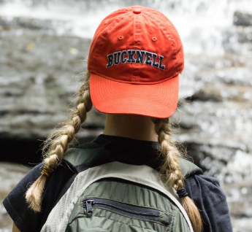
Some districts plan to approach the need for physical distancing by limiting the number of students who return at the same time. Typical labs and classrooms can accommodate 9 – 16 students, given the spacing recommendations. With state maximum class sizes of 33, that means making other arrangements for approximately half the students. School shifts, alternating day schedules and parent choice of year-long in-class or virtual learning are some of the options being considered. These School District Contacts can provide details on what is happening in your area.

To understand the constraints that drive re-opening decisions, consider these
health and safety recommendations that have been provided to school districts:
- CDC Considerations for Schools
  - CDC’s School Readiness and Planning Tool
- National Association of School Facilities Covid Guidance
- Georgia Department of Education: Covid-19 and Schools
- US Dept of Education Covid Information and Resources for Schools

Environmental Education providers will be most effective in partnering with schools if they can develop solutions that incorporate the following recommendations gleaned from the guidelines linked above:
- encourage physical distancing of at least 6 feet between individuals, including outdoor activities.
- reconfigure desks, seating, or work stations to face the same direction (inside and outside)
- increase circulation of outdoor air as much as possible (including outside learning)
- wear cloth face coverings
- install physical barriers such as plexiglass and mark visual guides in bathrooms and classrooms
- restrict nonessential visitors, volunteers, and activities involving external groups or organizations—especially those who are not from the local geographic area (e.g., community, town, city, country)
- pursue virtual activities and events in lieu of field trips, student assemblies, special performances
- no shared materials, lab supplies, or equipment, Disinfect durable equipment before next use.
- provide adequate supplies for handwashing and disinfection of shared surfaces (desks, tables)
- practice “cohorting” and limit mixing and mingling of student groups
- stagger arrival and drop off times and limit direct contact with parents
- designate a staff person for covid concerns and communications; limit exposure of high-risk staff
- check staff for symptoms; adjust leave policies to discourage sick people from coming to work
- train staff on safety protocols; cross-train staff in case of absences; and recruit back-up staff

How EE Providers Can Be Invaluable to School Districts
Remember that many school districts will adopt a tiered reopening plan, where restrictions are loosened as benchmarks are met. If field trips to your facility or presentation of your programs on school grounds are not possible now, they may be later in the school year. Ask for a place at the table during planning. Focus on providing expertise to help districts create outdoor learning spaces and adopt outdoor learning as an instructional strategy. Provide professional learning workshops for teachers on how to teach and engage students outside, and offer to assist on a regular schedule. EE providers are allowed under CDC guidelines as local, essential visitors. Look for a niche you can fill, creating virtual field trips and distance learning content. Provide services to working parents who need in-person supervision of children when they are out of school or doing distance learning. Know the CDC Guidance for Park Administrators and watch for EEA workshops designed to provide resources and increase capacity of EE Providers.
Your Logo
Strategies for Re-Opening Schools
With Outdoor Learning

Your Organization Name Can Help!

Type of EE Provider
- Organization OR Individual (delete whichever word to the left does not apply)
Contact Info
Contact Person’s Name
Street Address, City and Zip
Phone Number and best time to call

Locations we Serve (or School Districts in our Area)
List communities or school districts here

Services and Expertise We Offer (delete services you can NOT provide and replace all red print)
Planning and Development of Outdoor Learning Spaces
- Planning partner for school re-opening
- inventory of campus assets and hazards
- Site analysis and recommended location of improvements
- Consulting regarding master planning and overall campus design
- Plans, specifications and recommendations for specific outdoor fixtures and facilities
- Sourcing and pricing of materials
- Creation or revitalization of outdoor learning spaces on school grounds
- Coordination of school or community volunteers

Professional Learning and Support for Teachers
- Professional Learning Workshops for Teachers
  - Provide title of workshop(s) here, such as Project Wet, Project Wild, Project Learning Tree or other program for which you have a facilitator on staff
  - Customized workshops at your school
  - Mentoring, coaching and in-person assistance with outdoor learning
- Our staff to assist your teachers with outdoor learning at your schools
  - Available to be credentialed through the school district’s child protection screening
  - Our staff available as contract workers, part time employees, or by cooperative agreement
  - Some volunteer services available

Direct Instruction
- Virtual field trips, webinars, Ask an Environmental Educator, other remote learning options
- Off campus field trips for students, as soon as advisable in a tiered school reopening plan
- In-school programs and presentations – in the schoolyard or the classroom - as allowed
  - Ask for our catalog of available lessons and programs
  - Let us customize standards-based lessons for any grade level
- Supervision of distance learning for students and their families, on out-of-school days
- Outdoor Learning “Specials” Rotation at our location or your school
  - Scavenger hunts, citizen science, bio-blitzes, investigations, project-based learning

UPLOAD THIS PROFILE TO YOUR ORGANIZATION’S PROFILE AT www.eeingeorgia.org and use as a cover sheet for Executive Summary and Strategies for Re-Opening Schools with Outdoor Learning

