The Eco-Engineering Design Process
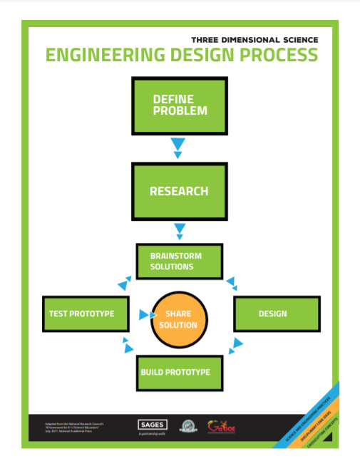
Eco-Engineering Challenges

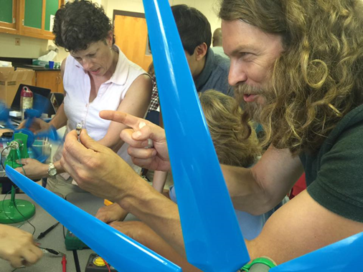
What teachers provide:
- a problem to solve
- design constraints (time, cost, specs)
- variety of materials
- minimum of coaching
- no preconceived outcomes
- opportunity to test and refine
- a gallery walk or other opportunity
for students to share their work

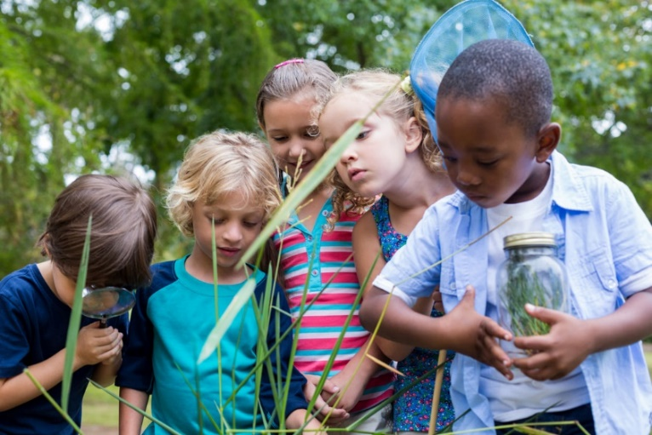
What students provide:
- curiosity and creativity
- resourcefulness
- research
- a design
- a prototype
- testing of prototype
- refinements to prototype
- re-testing

The hardest part: vulnerability / fear of failure

Tips for Modifying Traditional Lessons into EcoEngineering Challenges
- Provide safety information and equipment
- Remove step-by-step directions
- Release expectations for identical results
- Value ideas from students diverse perspectives, cultures and experiences
- Engage students in engineering design process
- Provide a wide variety of materials
- Clarify constraints
- Plan time for research, design, building, testing, refinement and sharing
- Focus on process; not outcomes
- Avoid pre-conceived notions about what roles each student should play
- Collaboration, creativity and communication are important 21st c skills but innovation often comes from outlier ideas that others do not value: be flexible about group vs individual projects when possible

Example: The Lost Ladybug citizen science project
- Scientists need us to collect, observe, and record data on ladybugs to help determine if the elusive nine-spotted ladybug is extinct, but we don’t have equipment to catch ladybugs. How can we do this?
Note: The Lost Ladybug Project comes with instructions for making nets

Today’s Teacher Challenge: How would you convert the lesson instructions to an eco-engineering challenge? Complete the form labeled “Teacher-Provided Information.”

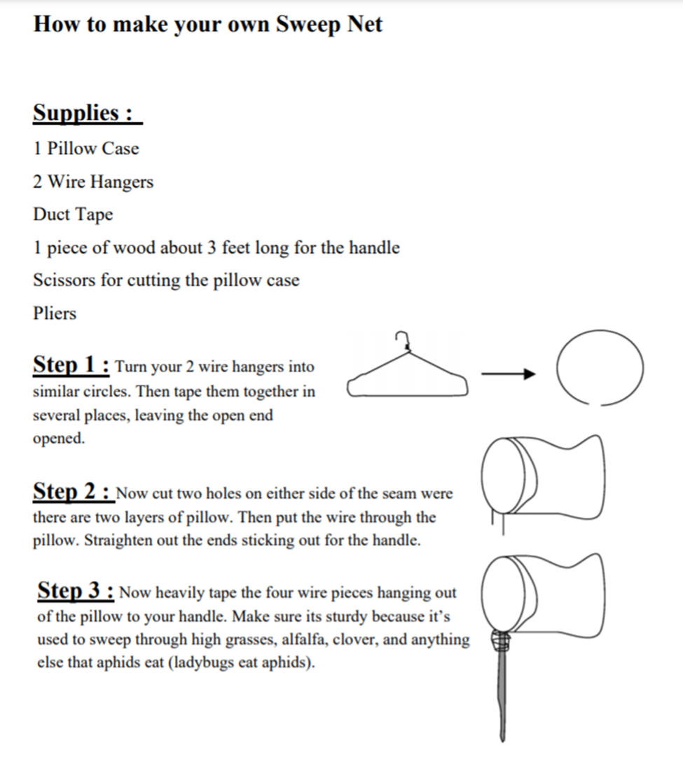
Teacher-Provided Information for
Eco-Engineering Challenge: Lost Ladybug Catcher

The Challenge (Include information on how to observe a key scientific phenomenon and make sense of it, to launch this eco-engineering challenge. Specify which parts of the challenge will be conducted outside)

Constraints

Materials Available

Curated Research Articles

Student Lab Report for
Eco-Engineering Challenge: Make a Ladybug Catcher
PROBLEM

RESEARCH FINDINGS
- .
- .
- .
- .
- .

BRAINSTORMING

DESIGN: labeled drawing
BUILD: then insert or paste a photo of what you built

TESTING: describe how you tested your prototype; what worked; what didn’t

REFINEMENTS: how did you change your design? Did it affect performance?

